Workflow chart in terms of Direct Guest

📞 SOP Requirements (Calls) – Postcard Hotels
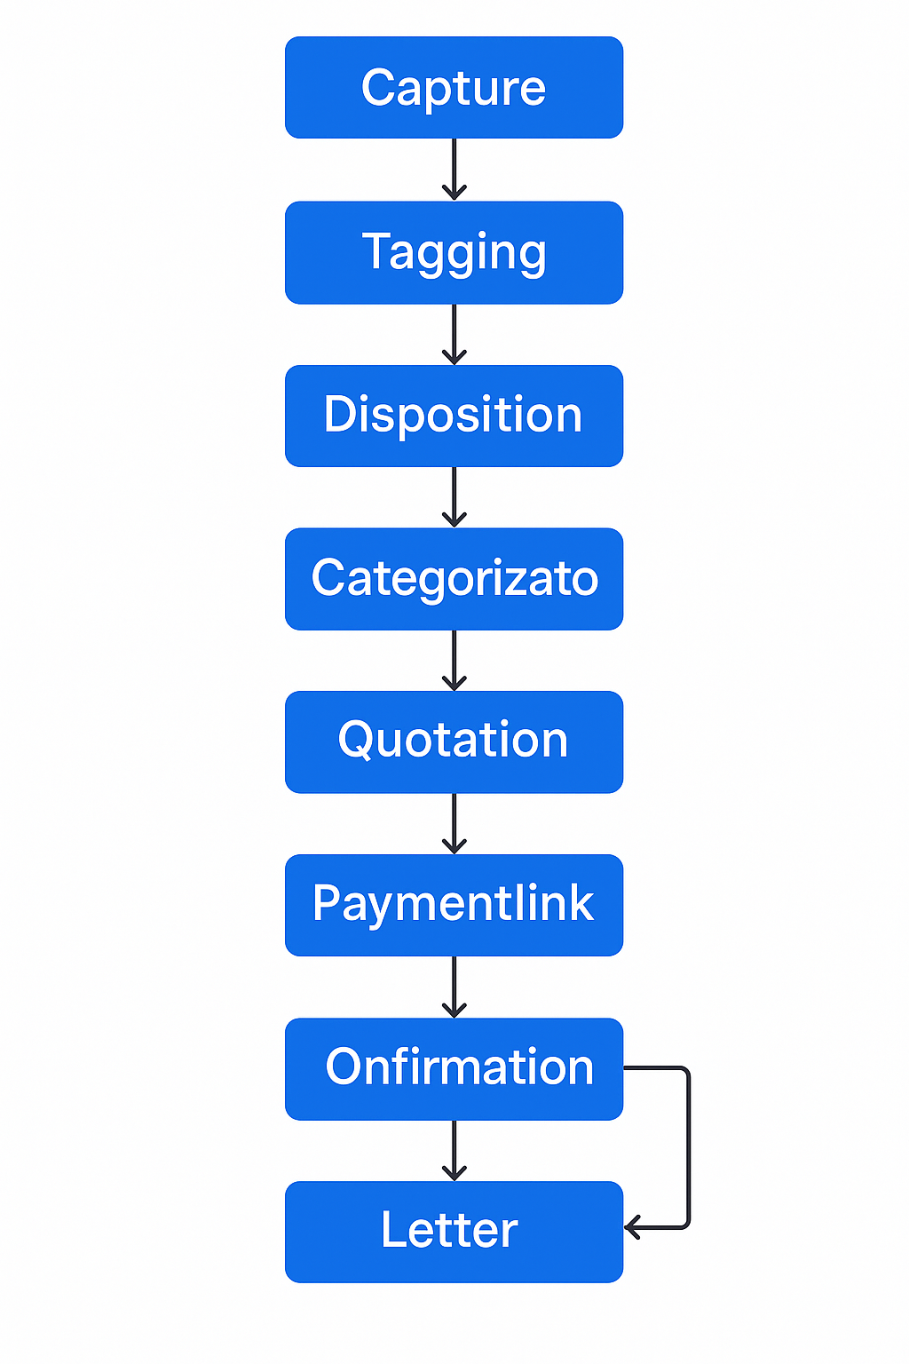

📞 Lead Call ( Direct Guest)
- Capture guest details: Name, contact, travel dates, hotel, occasion, occupancy, first-time/repeat.
- Tag lead as Direct Guest.
- Use drop-down to mark call status: Quotation Shared, Payment Pending, Not Interested.
- Categorize lead as Hot, Warm, or Cold.
- Share quotation via WhatsApp/email.
- Send automated follow-up SMS till day before arrival.
- Auto-send 50% advance payment link.
- If partial payment, mark as On Hold, show pending amount.
- On full payment, mark as Confirmed, log booking.
- Send a confirmation letter via guest's preferred channel.

A. Example Call Dispositions
- Shopping Call – Initial inquiry received from a direct guest exploring stay options.
- Shopping Follow-Up Call – Follow-up conversation on an existing lead that is still under discussion.
- Shopping – No Follow-Up – The guest has clearly communicated that they do not wish to proceed with the booking.
- Information/General Query – Call pertains solely to hotel-related information such as spa services, in-house activities, pet policies, etc., without a stay-related inquiry.
- Dining/Restaurant Inquiry – Guest inquiry limited to restaurant or dine-in services, not involving accommodation.
- Reservation Confirmed – Lead successfully converted into a confirmed reservation during the same call.
- Cancellation Request – Call received for cancellation of an existing reservation. (Stating the reasons of cancellation as well)
- Amendment Request – Guest requests changes to an existing reservation such as dates, number of rooms, guest names, etc.
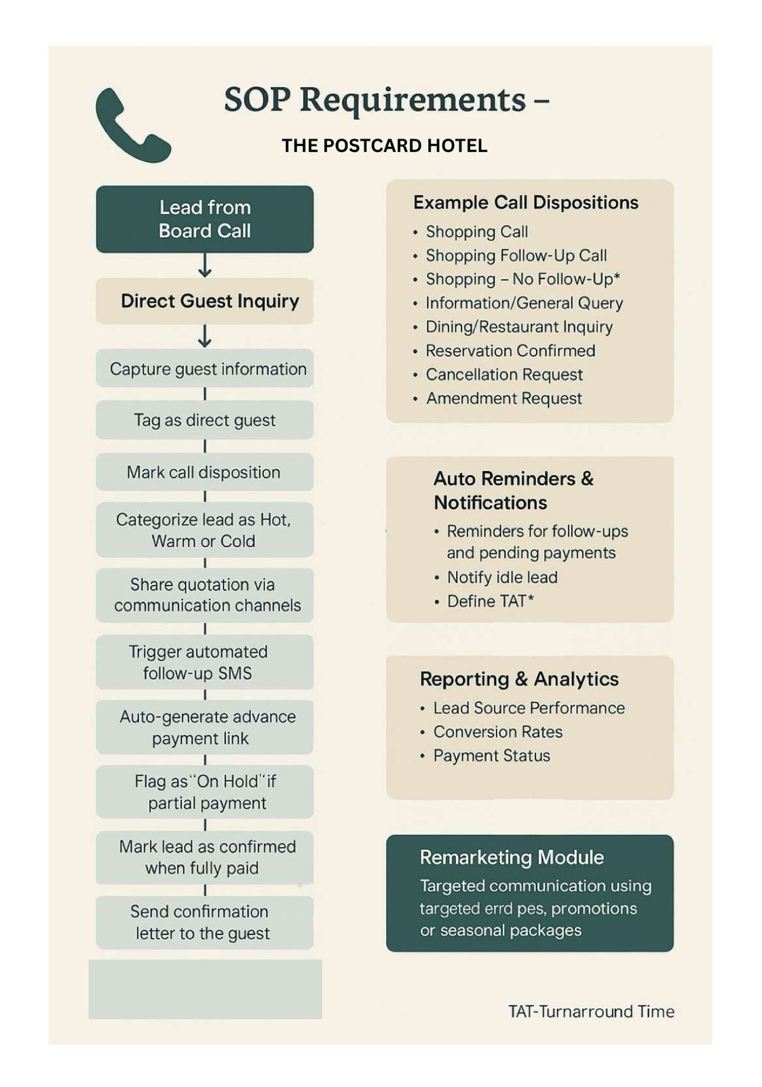
Dining – Direct Guest Call Process:
Step 1 – Gather complete information from the guest, including name, email, phone number, and property name.
Step 2 – Generate a lead for the operations team in the form of a ticket.
Step 3 – Assign the lead to the concerned operations team.
Step 4 – Add the guest to the database and include them in future email communications.
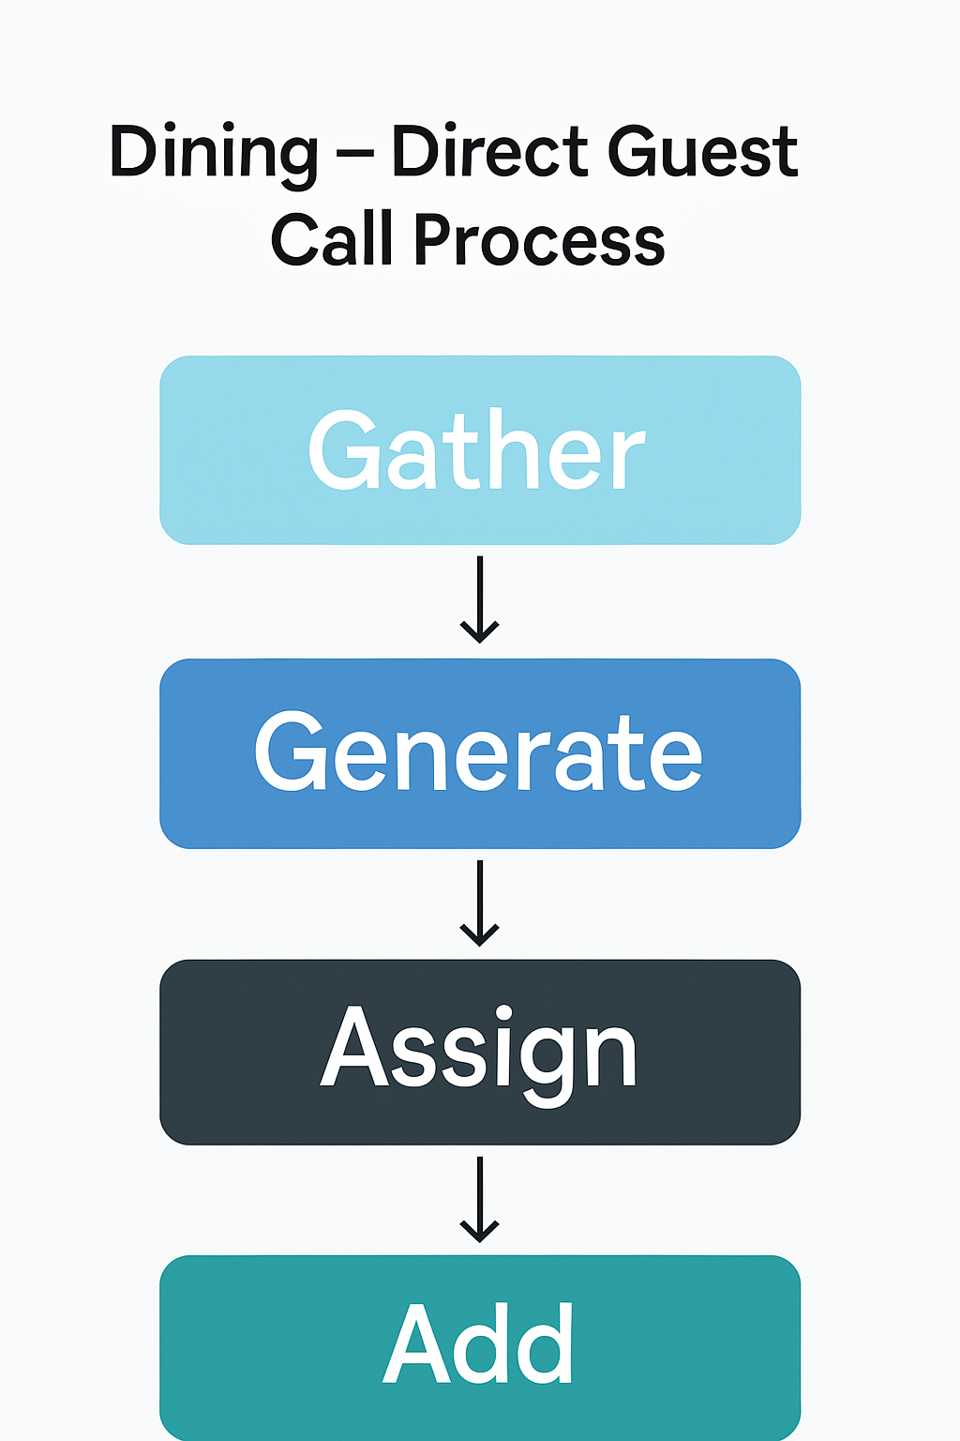
Direct Guest Call ( Regarding the information about the property)
Step 1: Gather complete information from the guest, including name, email, phone number, and property name.
Step 2: Tag the call as an Information/Shopping Call.
Step 3: Briefly explain key highlights of the property (location, USP, dining, experiences).
Step 4: Share the hotel brochure or relevant information via WhatsApp or Email.
Step 5: Check if the guest would like a quotation or further assistance with planning their stay.
Step 6: Add the guest details to the database for future reference.
Step 7: Include the guest in upcoming email communications, offers, and promotions.
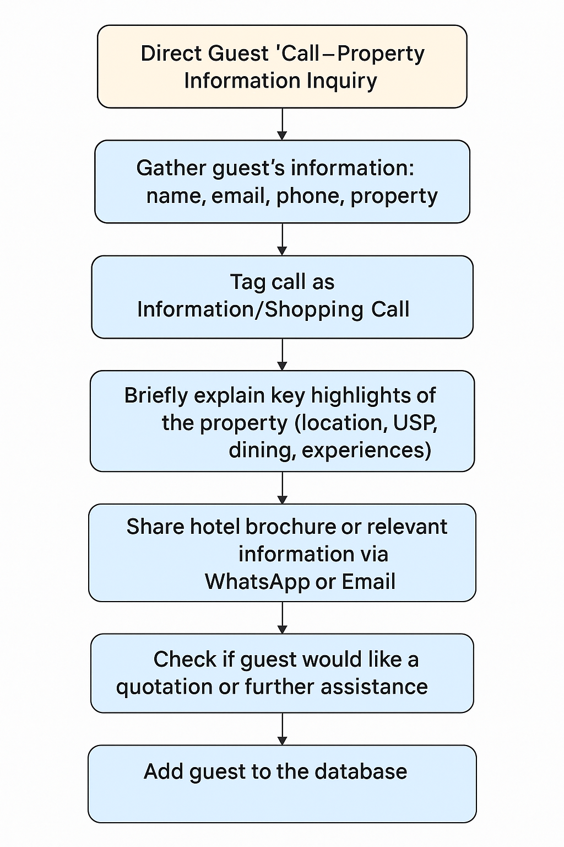
🏢 Call SOP – Travel Agents / Corporate Leads
Step 1: Collect the following details:
- Caller Name
- Company Name
- City/Location
- Requirement Details (Rooms, Event Space, Long Stay, etc.)
- Preferred Property
Step 2: Create a lead in the system/ticketing tool
Step 3: Assign the lead to the concerned sales representative for that region
- Notify the assigned team for timely follow-up

